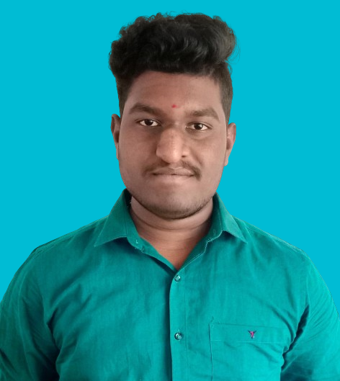 **Boovesh G**

**Email ID** : [boovesh.g2102003@gmail.com](mailto:boovesh.g2102003@gmail.com)

**Mobile No** : 8270598749

**Address**  :1/46 Koondhapnai kadu ,

Singalandhapuram (PO), Rasipuram (TK),

Namakkal (DT) – 637412.

_______________________________________________________________________________________

**CAREER OBJECTIVE**

I am seeking a role in a company where I can contribute my ideas and be menstored towards a successful career.

**ACADEMIC QUALIFICATION**

|  |  |  |  |  |
| --- | --- | --- | --- | --- |
| **Course** | **Name of the institution** | **Board of Study** | **CGPA/Percentage** | **Year of Passing** |
| BE -Computer Science And Engineering | Muthayammal  Engineering College (Autonomous), Rasipuram. | Anna University | 7.5 | 2025 |
| HSC | Kalaimagal Matric Hr Sec School  Belukurichi | State Board | 80% | 2021 |
| SSLC | Kalaimagal Matric Hr Sec School  Belukurichi | State Board | 75% | 2019 |

**TECHNICAL SKILLS**

* Beginner in Java,MYSQL.

**PROFESSIONAL PROFICIENCY**

**Workshop :** Attended workshop on “ FullStack Devlopment ”and “ IOT ” in

Pavai Engineering College

**Certification :** Completed the course “Front End Development” in the Great Learning

Platform.

Completion of NPTEL in IOT with 54%.

Completion of NPTEL in Distributed System with 73%.

**Paper Presentation :** Attended Paper Presentation at Tagore college of Engineering on “**Blue Eye Technology**”, and Attended Paper Presentation at Salem College of Technology on “**Cyber Security**”.

**TOOLS**

* MS Word,MS Power Point,MS Excel,GoogleSheets,John The Ripper,Kali Linux(Beginner).

**AREA OF INTEREST**

* Ethical Hacking
* Augmented Reality & Virtual Reality

**PERSONAL TRAITS**

* Self motivation
* Adaptability

**MINI PROJECT**

* Plant Leaf Identification by using python .

**PERSONAL INFORMATION**

**Parent’s Name** : Mr.M.Gopi & Mrs.G Saratha

**Date of Birth** : 02-10-2003

**Blood Group** : AB(+ve)

**Language Known** : Tamil and English

**DECLARATION**

I hereby declare that all the information stated above are correct to the best of my knowledge and belief.

**Date**  : 02/07/2024 Boovesh G

**Place**  : Rasipuram  **Signature**